EXP – 1

AIM:
To create a Smart City Information Portal web page that displays a structured layout with images, navigation links, and an embedded Google Map using HTML and CSS. The web page is styled using embedded CSS to enhance visual presentation. This experiment helps in understanding how to design a multi-section layout, integrate external links, embed maps using iframe, and apply CSS effects such as hover transitions, shadows, gradients, and responsive alignment for creating a professional smart city themed website.

ALGORITHM:

1. Create the Basic HTML Structure:
• Begin with the standard HTML document structure using <!DOCTYPE html>, <html>, <head>, and <body> tags.
• Specify the language attribute in the <html> tag.
• Add <meta charset="UTF-8"> for proper character encoding.
• Define the title of the webpage inside the <title> tag as Smart City Information Portal.
• Add embedded CSS inside the <style> tag within the <head> section.

2. Design the Page Background and Overlay:
• Set a background image for the body using CSS.
• Use background-size: cover to make the image fully cover the page.
• Create a div with class overlay to apply a semi-transparent dark layer.
• Use rgba() color values to create transparency.
• Align all content vertically using flexbox properties.

3. Create the Header Section:
• Add a <header> element inside the overlay.
• Insert the title Smart City Information Portal.
• Add a subtitle “Digital • Sustainable • Intelligent”.
• Apply gradient background styling using linear-gradient().
• Add border-radius and spacing for a modern UI design.

4. Create the Main Container Layout:
• Create a div with class container.
• Use display: flex to arrange three sections horizontally.
• Divide the layout into three parts:
- Left Section (Smart Dashboard)
- Center Section (City Monitoring Map)
- Right Section (Citizen Services)
• Apply box-shadow and border-radius for visual enhancement.

5. Add Image with Clickable Link:
• Insert an image inside the left section using the <img> tag.
• Wrap the image inside an <a> tag to make it clickable.
• Set the hyperlink reference to the official Smart Cities Mission website (https://smartcities.gov.in/).
• Use target="_blank" to open the link in a new tab.
• Apply hover scaling effect using CSS transform: scale().

6. Embed Google Map Using iframe:
• Inside the center section, use the <iframe> tag.
• Copy and paste the Google Maps embed link of Coimbatore.
• Set width, height, loading, and allowfullscreen attributes.
• Style the iframe using CSS (rounded corners and no border).
• Add descriptive text below the map.

7. Add Navigation Links:
• Inside the right section, use <a> tags to create navigation links.
• Add link to Government of Tamil Nadu (https://www.tn.gov.in/).
• Add link to National Portal of India (https://www.india.gov.in/).
• Use target="_blank" to open links in a new tab.
• Apply hover color effects using CSS.

8. Add Footer Section:
• Insert a <footer> element at the bottom of the page.
• Add copyright text and year.
• Style it with a dark background and rounded corners.

9. Test the Webpage:
• Open the webpage in a browser.
• Verify that:
o The background image loads correctly.
o The Smart Dashboard image redirects properly.
o The embedded Google Map displays correctly.
o Government links open in a new tab.
o Hover effects and transitions work smoothly.

PROGRAM:

Index.html:
<!DOCTYPE html>
<html lang="en">
<head>
<meta charset="UTF-8">
<title>Smart City Information Portal</title>

<style>
body {
margin: 0;
font-family: Arial, sans-serif;
background: url("https://encrypted-tbn0.gstatic.com/images?q=tbn:ANd9GcTEjM0UawOAy8tzc5Ta6Hk9ejTAdqBSBt0qwg&s") no-repeat center center fixed;
background-size: cover;
}

.overlay {
background: rgba(10, 25, 47, 0.75);
min-height: 100vh;
color: white;
display: flex;
flex-direction: column;
align-items: center;
}

header {
background: linear-gradient(90deg, #00c6ff, #0072ff);
text-align: center;
padding: 15px;
font-size: 18px;
letter-spacing: 1px;
width: 80%;
border-radius: 10px;
margin-top: 20px;
}

.container {
display: flex;
justify-content: center;
gap: 30px;
margin-top: 40px;
width: 80%;
}

.left, .right {
width: 20%;
background: rgba(0, 0, 0, 0.6);
padding: 12px;
text-align: center;
border-radius: 12px;
box-shadow: 0 0 10px #00f7ff;
}

.center {
width: 35%;
padding: 12px;
text-align: center;
background: rgba(0, 0, 0, 0.6);
border-radius: 12px;
box-shadow: 0 0 15px #00f7ff;
}

img {
width: 90%;
border-radius: 10px;
cursor: pointer;
transition: transform 0.4s;
}

img:hover {
transform: scale(1.05);
}

iframe {
width: 100%;
height: 250px;
border-radius: 10px;
border: none;
}

a {
text-decoration: none;
color: #00f7ff;
font-weight: bold;
transition: 0.3s;
}

a:hover {
color: #00ff88;
}

footer {
background: rgba(0, 0, 0, 0.8);
text-align: center;
padding: 10px;
font-size: 14px;
margin-top: 50px;
width: 80%;
border-radius: 10px;
}

h3 {
color: #00f7ff;
font-size: 16px;
}
</style>
</head>

<body>

<div class="overlay">

<header>
🌆 Smart City Information Portal <br>
<small>Digital • Sustainable • Intelligent</small>
</header>

<div class="container">

<div class="left">
<h3>🏙 Smart Dashboard</h3>
<a href="https://smartcities.gov.in/" target="_blank">
<img src="https://encrypted-tbn0.gstatic.com/images?q=tbn:ANd9GcTdZLdjv2-maf49Nv1mGaJkEcMdSm1rlY89zg&s">
</a>
<p>Click image to explore Smart City Mission</p>
</div>

<div class="center">
<h3>📍 City Monitoring Map</h3>
<iframe src="https://www.google.com/maps/embed?pb=!1m18!1m12!1m3!1d3916.242354993298!2d76.95583287398032!3d11.016844992142826!2m3!1f0!2f0!3f0!3m2!1i1024!2i768!4f13.1!3m3!1m2!1s0x3ba859b9e1f1e4e1%3A0x6a8d8c9c4a4c3f99!2sCoimbatore%2C%20Tamil%20Nadu!5e0!3m2!1sen!2sin!4v1700000000000!5m2!1sen!2sin"
allowfullscreen="" loading="lazy"></iframe>
<p>Live Infrastructure Monitoring</p>
</div>

<div class="right">
<h3>📢 Citizen Services</h3>

<p>🔗 <a href="https://www.tn.gov.in/" target="_blank">
Tamil Nadu Government Portal
</a></p>

<p>🔗 <a href="https://www.india.gov.in/" target="_blank">
National Government Portal
</a></p>

<p>Click links to access services</p>
</div>

</div>

<footer>
© 2026 Smart City Portal | Future Ready City 🌐
</footer>

</div>

</body>
</html>

OUTPUT:
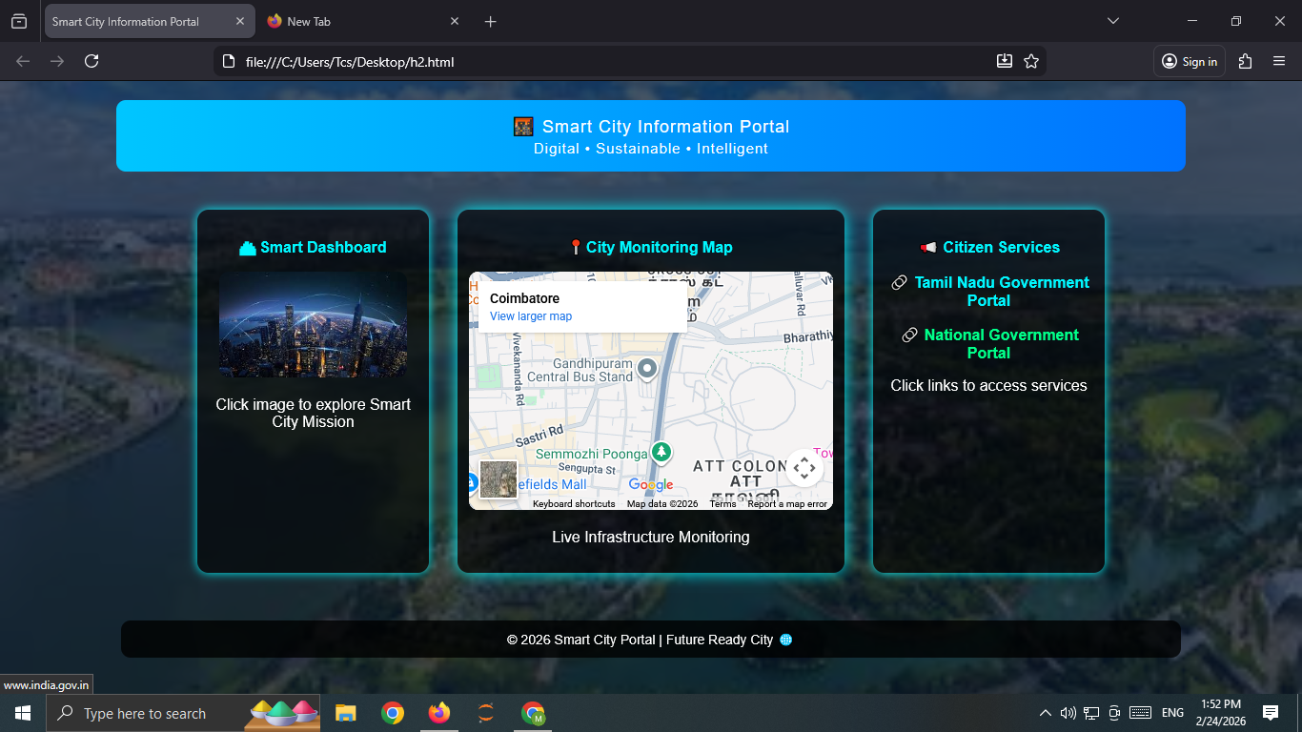

RESULT:
The Smart City Information Portal web page was successfully created with a structured layout, embedded Google Map, clickable image link, and navigation links. Embedded CSS styling was applied properly, and all interactive elements functioned correctly when tested in the browser.

